**🍕 Pizza Sales Analysis Dashboard**

**📌Overview**

This project presents a comprehensive sales analysis dashboard for a fictional pizza store, built using **Power BI**. It simulates a real-world business intelligence scenario by integrating data from **SQL Server**, transforming it, and visualizing key performance indicators (KPIs) to support data-driven decision-making.

**🛠️ Tools & Technologies**

* **Microsoft Excel** – Source data in CSV format
* **SQL Server Management Studio (SSMS)** – Database creation and query execution
* **SQL** – Data extraction, transformation, and KPI logic
* **Power BI** – Data modeling, visualization, and dashboard design

**📈 Project Workflow**

1. **Database Setup**
   * Created PizzaDB in SSMS
   * Imported CSV files into SQL Server tables
2. **Data Preparation**
   * Wrote SQL queries to answer business questions (e.g., top-selling pizzas, peak order times, revenue trends)
   * Cleaned and structured data for analysis
3. **Power BI Integration**
   * Connected SQL Server database to Power BI
   * Loaded and transformed data using Power Query
4. **DAX**
   * Created calculated columns and measures for KPIs (e.g., Total Sales, Average Order Value, Daily Revenue)
5. **Dashboard Design**
   * Added visuals: bar charts, pie charts, line graphs, and cards
   * Used slicers for dynamic filtering (e.g., by date, pizza type, category)
   * Included navigation buttons for multi-page reports
   * Enhanced aesthetics with icons, images, and formatting

**📊 Key Insights Delivered**

* 🔥 Best-selling pizza categories and toppings
* 🕒 Peak order times and daily sales trends
* 💰 Revenue breakdown by day, category, and size
* 📦 Order volume and customer behavior patterns

**📷 Screenshots**

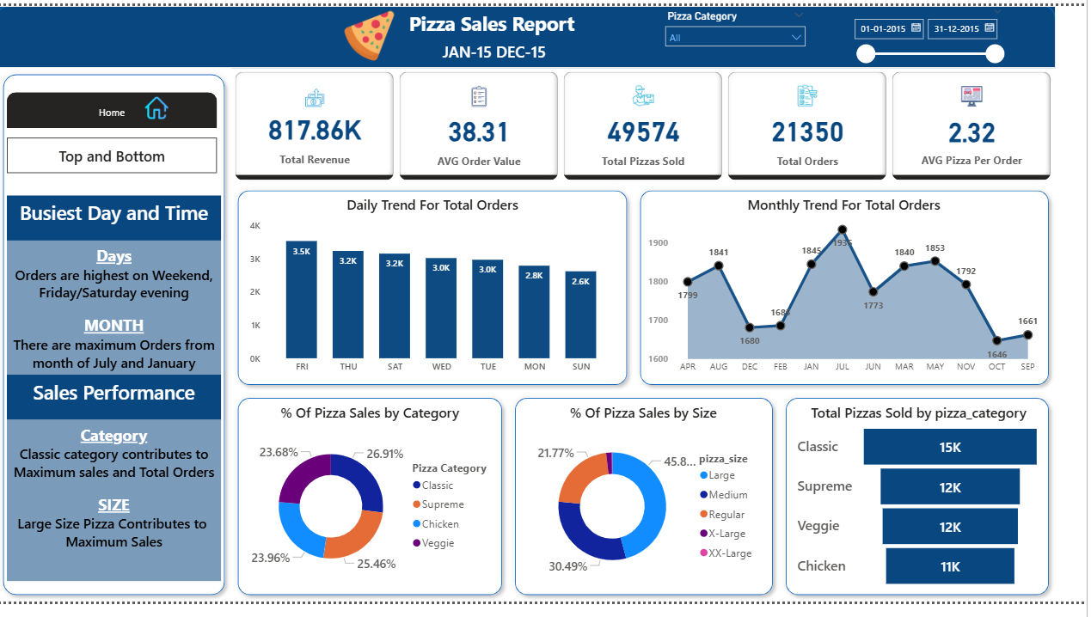

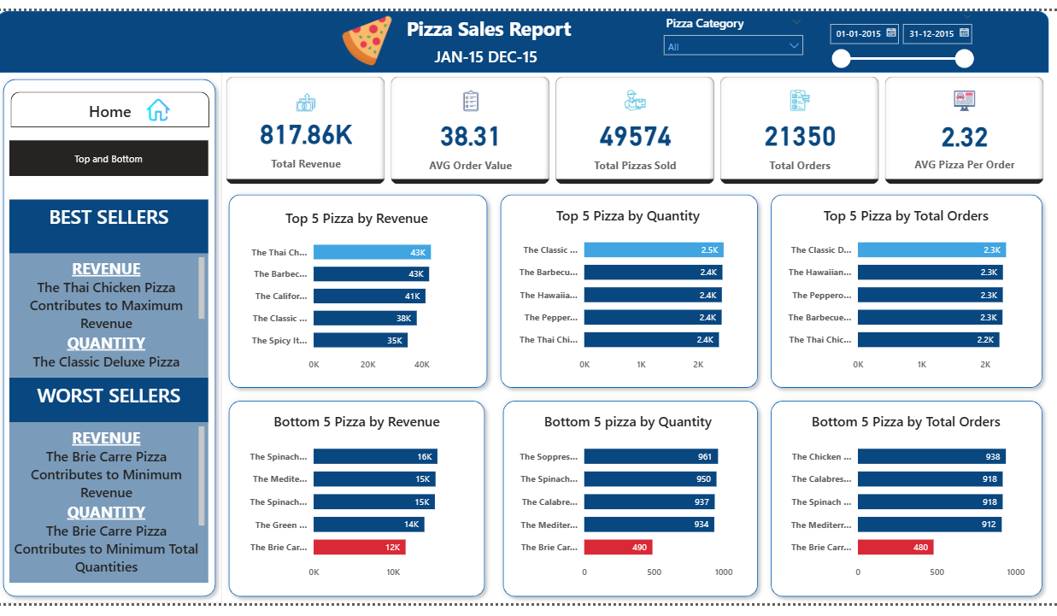

**🎯 Learning Outcomes**

* Hands-on experience with SQL-based data modeling
* Power BI dashboard creation with interactive features
* Real-world simulation of business analytics workflow
* Strengthened understanding of KPIs and storytelling with data